Triple B (Blazer Breeders Best) Rules and Regulations
Conformation and performance show for Blazer yearlings.

This incentive program is designed to encourage American Blazer Horse Association (ABHA) breeders to put forth the most correct and usable Blazer horse conforming to the breed standards. The continuation of the Blazer breed is dependent on breeders striving to produce a horse that is athletic, efficient, trainable and usable in a variety of equine sports, based on the current ABHA breed standards.

Rules:
1. This is an incentive fund and horse owners to be involved in the Triple B are to pay a fee at conception year (eligibility based on sire and/or dams registration refer to the Blazer handbook section IV 4.1), a fee at breeding year, birth year and a fee in showing year, yearling, to complete the total entry fee.
2. Horses involved in the Triple B must be the offspring of a Blazer sire or dam or both, as set forth in the Blazer handbook rules and regulations section IV 4.1. The future entry must be registered by Dec 31 of the birth year.
3. The owner must be a member in good standing with the American Blazer Horse Assn.
4. The Blazer Breeder's Best show, Triple B, will be an event sponsored by the ABHA for all qualified yearlings at a time, date and place designated by the ABHA. The event must take place if 2 or more entries are eligible. In the event that only one yearling is eligible, the event will be canceled for that year and the funds returned to the one applicant.

Show:

1. Eligible yearlings are described as any ABHA registered stallion, gelding, or filly whose birth year is the previous year of the show.
2. The show shall consist of two parts holding equal weight. Conformation and in-hand trail course.
Whatever the total points for the trail course are, the conformation class will be worth an equal amount of points.
a. Conformation will be judged according to the description and rules of registration set forth in the ABHA rule book section IV 4.7.
b. Trail course shall exhibit ease of handling, courage, movement and athleticism.
3. Show categories are as such:
a. Best stallion conformation b. Best stallion in hand
c. Best stallion overall
d. Best Filly conformation e. Best filly in hand
f. Best filly overall
g. Best gelding conformation h. Best gelding in hand
i. Best gelding overall
j. Grand champion(selected from all classes)
k. Reserve champion(selected from all classes)
l. Following placements of 3rd, 4th, 5th etc. dependent on total number of entries shown based on the table below.
4. The ABHA will provide a qualified judge.

Awards:
1. Will be provided by the ABHA and will/can consist of ribbons, trophies and monetary consideration. a. Monetary consideration will be determined on the number of entries and paid out according to
the pay table.
b. Monetary awards shall be a total of no less than 50% of total amount in the Triple B ABHA fund. Can consist of more than 50% of Triple B funds held by the ABHA, divided
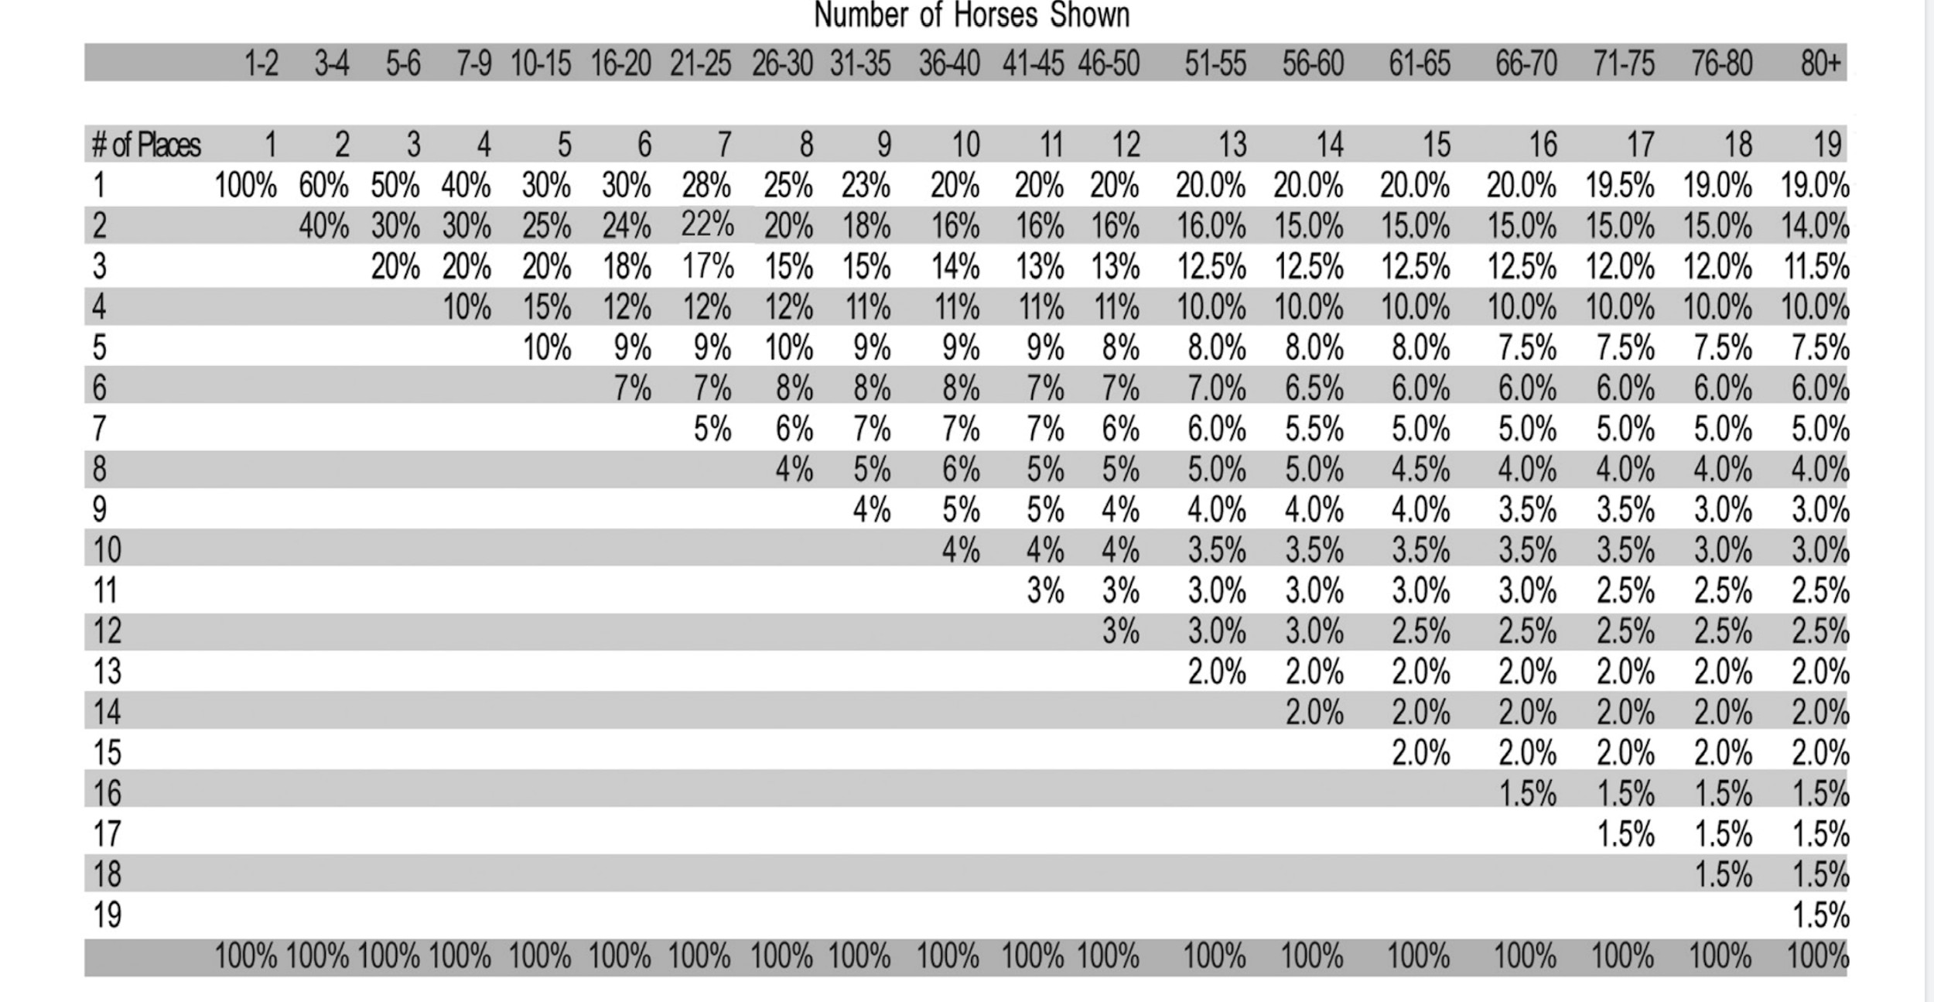
among show categories according to the pay table.
c. Ribbons and trophies provided will designate each eligible category shown with year
stated. For example: In any given year a stallion, gelding or filly category may not be filled in the show and therefore the ABHA would not be responsible for providing awards for that category.

General rules:
1. Exhibitor may or may not be the owner of the yearling, Exhibitor to be designated by owner of yearling.
All exhibitors must be a member of the ABHA. No one under the age of 18 shall be allowed to handle/show a Stallion at the Triple B. Other exhibitors must be at least 12 years of age to show in the mare or gelding divisions.
2. It is up to each owner to make sure their yearling is in “show shape”. To include body condition, grooming, trimmed and in handler's control. If any yearling is disqualified by ABHA or by the judge due to poor body condition or dangerous behavior all fees are forfeited by the owner.
3. All Exhibitors must be neat and professional in appearance. Button down, collared and long sleeve shirts are required. Show halters must be neat and humane. Rope halters are allowed.
4. All funds, registration fees and show fees, to be paid by owner (in a timely manner) of entered yearling unless waived and approved by ABHA. Each year's fee to be paid to ABHA by Dec 31st of the appropriate year and show year paid by July 1. A penalty may be assessed by the ABHA for untimely payment.
5. If entry fails to show on show day for any reason all previous payments paid by the owner are forfeited.
ABHA may consider special circumstances such as injury or death of entry.
6. ABHA may change or add rules at any time so long as all entries are notified in writing in a timely manner.
7. Obstacle course layout is the responsibility of the Triple B chairperson.
8. Course layout will be given to each participant at least 30 days prior to show.
9. All decisions of the judge, show management, and the ABHA are final.
Any questions, please contact us at
abhaawardsprogram@ gmail.com .

Revised July 1, 2025

